Proposal for new Little League Baseball Division and splitting of the T-Ball Division:
Presented by Sean Christopher

Name: Rookie League
Ages: Ages 5-7 (with at least one year of experience at the T-Ball Level and league approval to move up from t-ball based on ability.)

Rookie League:
- Pitching Machine League with manual pitching machine (Estimated cost of $200 per machine)
  - 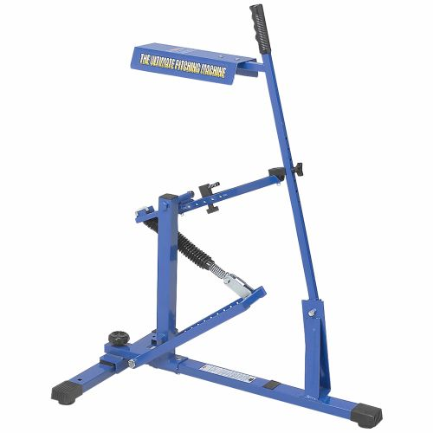
- 4 Innings Maximum
- 3 pitches with machine and 4th would be hit off the tee
- Pitching Machine set at 40 feet from plate.
- All kids on the field for defense and all kids in batting line-up each inning
- Coaches may be on the field with player defensively
- Coaches may be on the field at home plate offensively.
- End of t-ball season, coaches fill out a form and suggest a player is ready to move up to Rookie League. Board makes final approval of those players playing at the Rookie Level

T-Ball League:
- 4-6 year olds
- All parents must sign a volunteer form and be on the field defensively with the kids.
- All current rules apply

